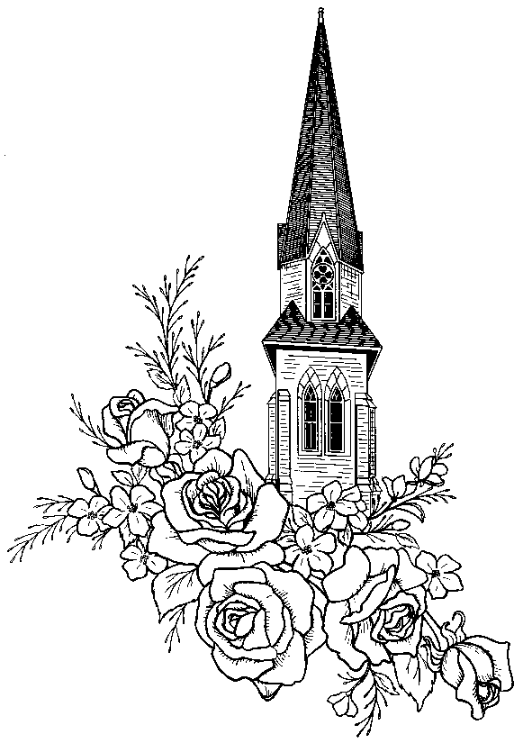
Deceased name

Funeral Home Name

Date of Birth ~ Date of Death

