Reflections of Life Software Instructions

1. Security Warnings
Macros
All templates contain macros. These templates will NOT function correctly without enabling them!
Check "Always trust macros from this publisher.”, and click “Enable Macros” when opening a template for the first time, this will only need to be done once.
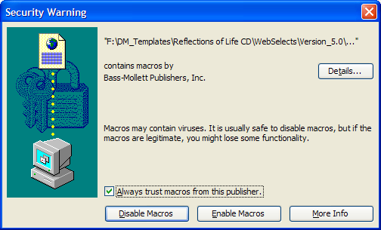
Note: If you do not receive this message and the templates are not working correctly, do the following.
Word 2000 – 2003
Click on Tools, Macros, Security, and make sure your security level is set to medium.
Then re-launch the template.
Word 2007 or above
Click on the office button, word options, trust center, trust center settings, and select “Disable all macros except digitally signed macros”. Click OK, and then re-launch the template.

2. Navigating the program
Navigating through the program is done by simply clicking on the buttons and following the onscreen instructions to open the desired templates.

3. Image Requirements
All images need to be scanned and saved to your computer prior to inserting them into the templates.
Bass-Mollett does not provide scanning capabilities.
- Sizes
  - Center Image 2”x3”
  - Collage Images
    - Vertical 2”x3”
    - Horizontal 3”x2”
- 200 dpi minimum

4. Toolbars
This toolbar was added to aid in using these templates. See descriptions of the buttons below.
For Word 2007 or above, users will need to click the “Add-ins” tab at the top of the page before seeing the toolbar below.
Use these buttons insert clipart, military, police and Fireman emblems on to the candle.
Use this button to change the shape of the picture.
Use these buttons to insert the collage option. 4 more images can be inserted onto the candle.
This button saves the template to a user defined location.
Use this button to print.
Use these buttons to change color, shape, and delete nameplate to type over background.

5. Filling Image Areas (Inserting Images)
Image areas in the templates are gray ovals or gray squares.
Use the instructions below to fill these areas with the desired image that you scanned earlier. See step 3
Word 2000-2003
Double click on the gray image area, select Format AutoShape, and choose the Colors and Lines tab. In the Fill area, click on the Color box and choose Fill Effects. Click on Picture tab, choose Select Picture. Find the desired picture, highlight, and click Insert. See Illustration below.
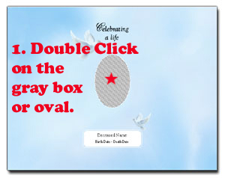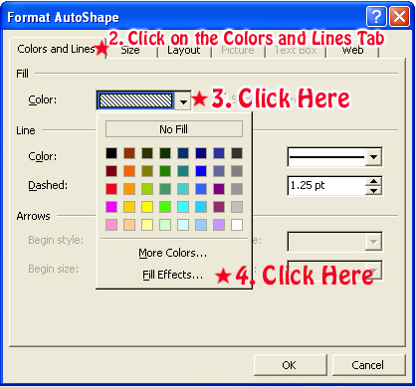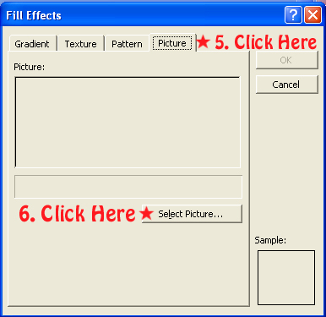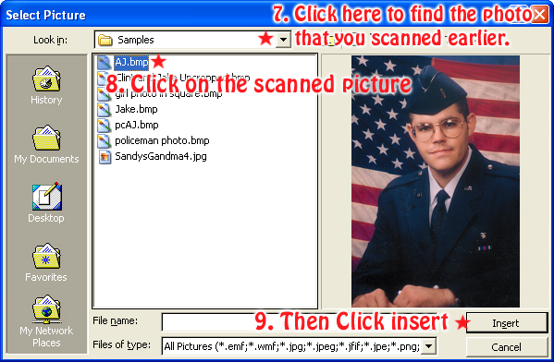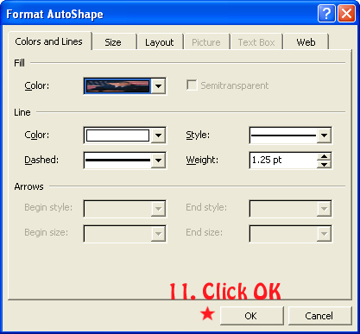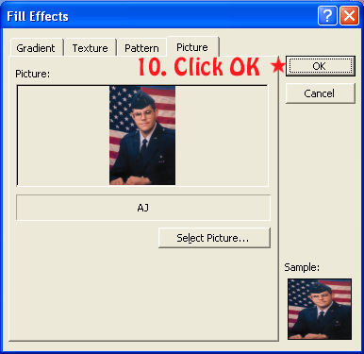

Word 2007 or above
Right click on the gray image area, select Format AutoShape, and choose the Colors and Lines tab. In the Fill area, click on the Color box and choose Fill Effects. Click on Picture tab, choose Select Picture. Find the desired picture, highlight, and click Insert. See Illustration below.
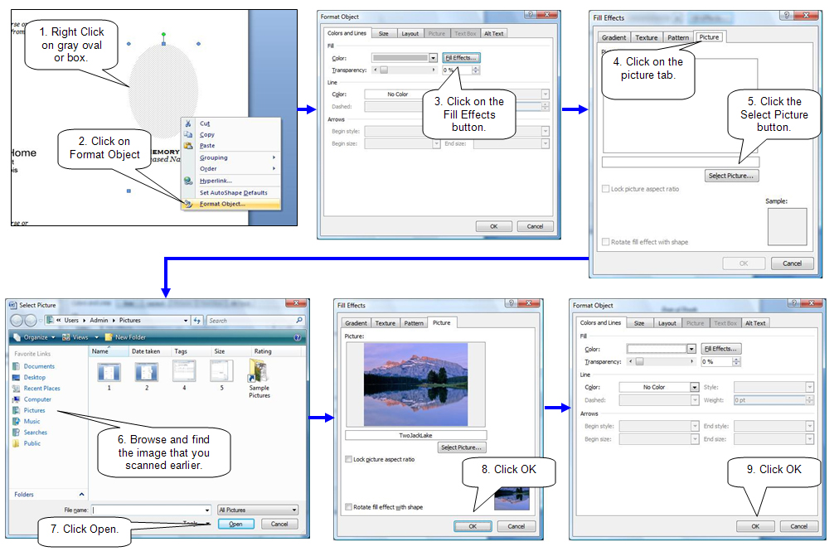
6. Changing the shape of the picture.
Click on the desired shape in the toolbar to change the image on the candle.
See section 4 of this document.
7. Filling in text boxes (Typing in your information)
Replace text in text boxes by highlighting the text and type the desired information in that area.
Reminder:

10. Saving template.
Saving the template for later use is a good practice incase the need for more cards, folders etc come up.
Click Save on the toolbar and browse to the desired location. Example: My Documents.
See section 4 of this document.

11. Printing
Print by clicking on the Print button on the toolbar.
See section 4 above.

12. Binder Option
Open the Binder by clicking the binder button in the program.
Once opened, Click Print.
Note: You can delete any images you don’t want to show your families.
Click on the image and hit the delete button on your keyboard.

If further instructions are needed, please contact us.

1.800.851.4046
Bass-Mollett Publishers, Inc.

